Architecture of Data pipeline for logs at Naukri.com
# Last amended: 27th Nov
# My folder: C:\Users\ashok\OneDrive\Documents\kafka
# The material here is taken from this article in Medium: “Centralizing logs at Naukri.com with Kafka and ELK stack”
A web application consists of various components and each of them generates logs. Few of them are mentioned below.
- Access logs from web servers like Nginx, Apache
- Logs from back end applications (Java, PHP, python etc.)
- Logs from Database, Cache system, Queues etc.
- System Logs from the server
This workflow is about how IT team centralized logs at naukri.com using Filebeat, Kafka, Logstash, Elasticsearch and Kibana.
Architectural Approach
Any centralized logging approach needs the following components:
Collection, Transport, processing/enrichment, Storage, Analysis and Alerting. There are tools already available to do each of them but orchestration is required to ensure that they are connected seamlessly. An inhouse tool AURA, is used for alerting and log correlation and RCA. Detailing for AURA as a alert management and correlation is a topic for another day.
Initial Approach:
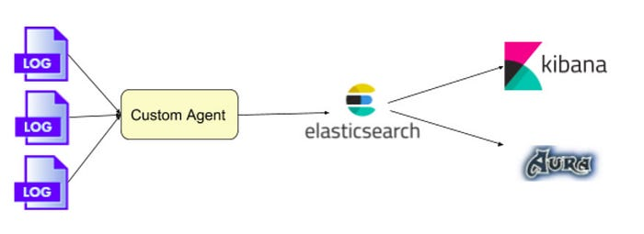
We started off with processing at the logs at source with a custom agent placed at each server and pushing the processed logs to a central store powered by an Elasticsearch cluster. Kibana was used for visualization and analysis of the logs.
This approach had the following advantages
- Ability to filter out unwanted logs or pre aggregate at the source itself thereby reducing the overall data transfer.
- Log processing at the source means lesser resource burden at the central location.
While this worked fine, we started facing challenges soon
- Changing of processing logic is very cumbersome as the logic has to be propagated to all servers
- Spikes in log production leading to Elasticsearch cluster unable to handle the load led to intermittent dropping of logs
- A central temporary log retention became necessary to minimize data loss.
Final Approach:
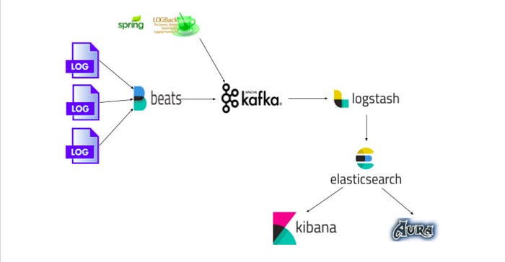

In order have a more resilient, easy maintenance and efficient system, we changed the stack to have minimal work done at the source and do all processing centrally. A kafka layer was also introduced to hold the logs temporarily to handle spikes and unexpected storage failures.
Each server has one or more application writing logs to the local disk. A Filebeat agent on each server, configured with multiple prospectors, picks up logs from different applications like nginx, apache, mysql and web applications and pushes to a central Kafka cluster.
************

